Министерство науки и высшего образования Российской Федерации

Федеральное государственное бюджетное образовательное учреждение

высшего образования

«Рязанский государственный радиотехнический университет имени В. Ф. Уткина»

Кафедра «Вычислительная и прикладная математика»

Отчет по лабораторной работе №4

по дисциплине «Объектно-ориентированное программирование»

на тему «Полиморфизм, абстрактные классы»

Выполнил: студент гр.1413

Аверкин М.Е.

Проверил:

доц. Антипов О.В.

**Цель работы**: освоить реализацию принципа полиморфизма, поработать с абстрактными классами. Выстроить правильную иерархию наследования.

**Задание**: 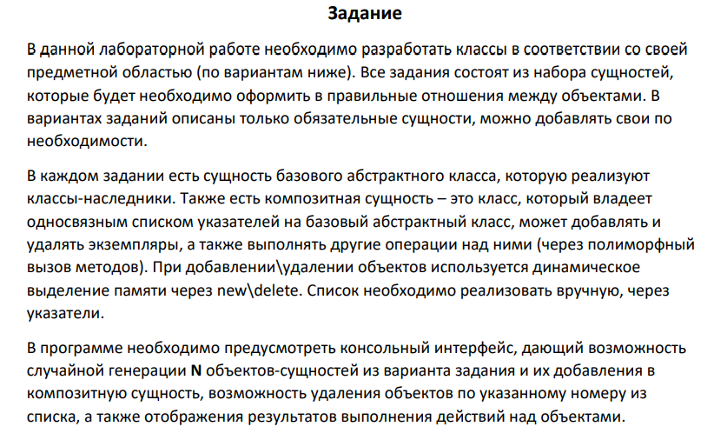

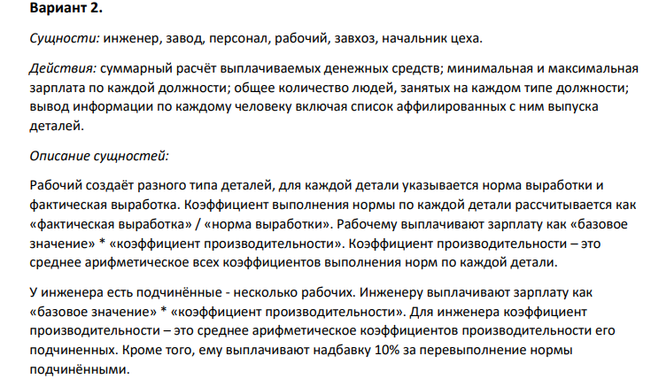

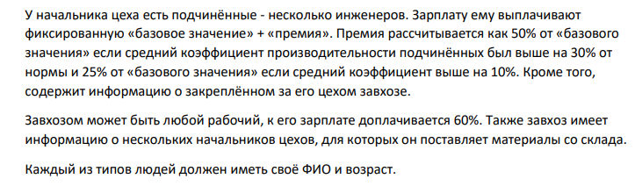

**Анализ программы:**

**Входные данные:**

Случайным образом генерируемые сущности, имена которых выбираются из заранее определенных массивов имен. Количество сущностей классов Factory, Worker, Engineer, Foreman, Manager.

**Промежуточные данные:**

Переменные N, numberOfChoise, numberOfPersomal выступающие в качестве параметров цикла for и оператора switch.

**Выходные данные:**

Композитная сущность класса Factory, которая хранит в себе ссылки на объекты классов, наследуемых от базового класса Personal.

**Описание структуры:**

Personal – абстрактный класс, с чистыми виртуальными функциями printInfoAboutPersonal и calculateSalary, которые будут переопределяться в классах-наследниках.

Detail – класс, добавлен для реализации изготавливаемой продукции. Поля – numberOfDetails (число деталей), normRate (норма выработки деталей), name (название данного вида изделия), factRate (фактическая выработка), koef(коэффициент выполнения нормы по каждой детали).

Randomization – класс, добавлен для реализации рандомизации заполняемой информации о персонале. Содержит в себе 4 массива имен: для имен, фамилии, названия завода, название детали.

Engineer – класс – наследник класса Personal.. Выступает родительским классом для класса Worker. Хранит в себе список с информацией о починенных ему рабочих. Добавлены методы получения списка рабочих, получения количества подчиненных ему рабочих и среднего коэффициента выполнения нормы.

Foreman – класс – наследник от класса Personal.. Выступает родительским классом для класса: Engineer. Хранит в себе список с информацией о починенных ему инженерах. Добавлены методы получения списка инженеров, получения количества подчиненных ему инженеров и дополнен метод расчёта зарплаты.

Manager – класс – наследник от класса Personal. Выступает родительским классом для класса: Foreman. Хранит в себе список с информацией о начальниках цеха. Добавлен метод расчёта числа начальников цеха и получения списка начальников цеха, дополнен метод расчёта зарплаты.

Worker – класс – наследник от класса Personal. Хранит в себе список деталей с информацией о них и о их количестве. Добавлен метод расчета среднего коэффициента выполнения нормы.

Factory – композитная сущность, хранит в себе список указателей на объекты базовой сущности Personal. Имеет методы расчета суммарных выплат по всему персоналу.

**Листинг программы:**

**Factory.h**

#pragma once

#include "Personal.h"

class Factory{

Personal** listOfPersonals;

string name;

int capacityOfPersonals;

public:

~Factory();

Factory(string name) {

this->name = name;

capacityOfPersonals = 0;

}

void extendListOfPersonals(int capacity);

void addNewPersonal(Personal& personal);

float getPayouts();

void printInfoAboutMinMaxSalary();

void printInfoAboutPersonal();

void printInfoAboutPersonalByPost();

void deleteById(int id);

int getCapacityOfPersonals(){

return capacityOfPersonals;

}

};

**Factory.cpp**

#include "Factory.h"

#include "Worker.h"

Factory::~Factory(){

cout << "Factory dtor" << endl;

delete[] listOfPersonals;

}

float Factory::getPayouts(){

float summPayout = 0;

for (int i = 0; i < capacityOfPersonals; i++) {

summPayout += listOfPersonals[i]->calculateSalary();

}

return summPayout;

}

void Factory::printInfoAboutMinMaxSalary()

{

for (int i = 1; i < 5; i++) {

cout << "For post " << arrayOfPosts[i] << endl;

float minSalary = 10000000;

for (int j = 0; j < capacityOfPersonals; j++) {

if (listOfPersonals[j]->getPost() == arrayOfPosts[i]) {

if (listOfPersonals[j]->calculateSalary() < minSalary) {

minSalary = listOfPersonals[j]->calculateSalary();

}

}

}

cout << "Minimal salary: " << minSalary << endl;

float maxSalary = 0;

for (int j = 0; j < capacityOfPersonals; j++) {

if (listOfPersonals[j]->getPost() == arrayOfPosts[i]) {

if (listOfPersonals[j]->calculateSalary() > maxSalary) {

maxSalary = listOfPersonals[j]->calculateSalary();

}

}

}

cout << "Maximum salary: " << maxSalary << endl;

}

}

void Factory::printInfoAboutPersonal()

{

for (int i = 0; i < capacityOfPersonals; i++) {

listOfPersonals[i]->printInfoAboutPersonal();

}

}

void Factory::printInfoAboutPersonalByPost()

{

for (int i = 1; i < 5; i++) {

int totalCounter = 0;

for (int j = 0; j < capacityOfPersonals; j++) {

if (arrayOfPosts[i] == listOfPersonals[j]->getPost()) {

totalCounter++;

}

}

cout << "Total number of personal on post " << arrayOfPosts[i] << " : " << totalCounter << endl;

}

}

void Factory::deleteById(int id)

{

Personal& newPersonal = *(new Worker("Deleted worker", 0, 0));

newPersonal.setPost("DEFAULT");

listOfPersonals[id] = &newPersonal;

}

void Factory::extendListOfPersonals(int capacity)

{

if (capacity <= capacityOfPersonals) {

return;

}

else {

Personal** newListOfPersonals = new Personal * [capacity];

for (int i = 0; i < capacityOfPersonals; i++) {

newListOfPersonals[i] = listOfPersonals[i];

}

delete[] listOfPersonals;

listOfPersonals = newListOfPersonals;

}

}

void Factory::addNewPersonal(Personal& personal)

{

this->extendListOfPersonals(capacityOfPersonals + 1);

this->listOfPersonals[capacityOfPersonals] = &personal;

capacityOfPersonals++;

}

**Personal.h**

#pragma once

#include <stdlib.h>

#include <string>

#include "Detail.h"

using namespace std;

const string arrayOfPosts[5] = { "Default", "Worker", "Engineer", "Foreman", "Manager" };

enum posts {

DEFAULT,

WORKER,

ENGINEER,

FOREMAN,

MANAGER

};

class Personal

{

string fio;

string post;

int age;

int BaseValue;

public:

virtual void printInfoAboutPersonal() = 0;

virtual ~Personal();

virtual float calculateSalary() = 0;

void setPost(string post) {

this->post = post;

}

string getPost() {

return post;

}

Personal(){

}

Personal(string fio, int age, int BaseValue) {

this->age = age;

this->fio = fio;

this->BaseValue = BaseValue;

this->post = arrayOfPosts[DEFAULT];

}

int getBaseValue() {

return BaseValue;

}

void setBaseValue(int BaseValue) {

this->BaseValue = BaseValue;

}

string getFio() {

return fio;

}

void setFio(string fio) {

this->fio = fio;

}

int getAge() {

return age;

}

void setAge(int age) {

this->age = age;

}

};

**Personal.cpp**

#include "Personal.h"

Personal::~Personal()

{

cout << "Personal dtor" << endl;

}

**Worker.h**

#pragma once

#include "Detail.h"

#include "Personal.h"

class Worker:public Personal

{

Detail** listOfDetails = nullptr;

int numberOfDetails;

public:

~Worker();

Worker(string name, int age, int base){

this->setFio(name);

this->setAge(age);

this->setBaseValue(base);

this->setPost(arrayOfPosts[WORKER]);

numberOfDetails = 0;

}

void extendListOfDetails(int capacity);

void addNewDetail(Detail& detail);

Detail** getListOfDetails() {

return listOfDetails;

};

float getAverageKoef();

void printInfoAboutPersonal() override;

float calculateSalary() override;

};

**Worker.cpp**

#include "Worker.h"

Worker::~Worker()

{

cout << "Worker dtor" << endl;

delete[] listOfDetails;

}

void Worker::extendListOfDetails(int capacity)

{

if (capacity <= numberOfDetails) {

return;

}

else {

Detail** newListOfDetails = new Detail * [capacity];

for (int i = 0; i < numberOfDetails; i++) {

newListOfDetails[i] = listOfDetails[i];

}

delete[] listOfDetails;

listOfDetails = newListOfDetails;

}

}

void Worker::addNewDetail(Detail& detail)

{

this->extendListOfDetails(numberOfDetails + 1);

this->listOfDetails[numberOfDetails] = &detail;

numberOfDetails++;

}

float Worker::getAverageKoef()

{

float averageKoef = 0.0f;

float summaryKoef = 0.0f;

for (int i = 0; i < numberOfDetails; i++) {

summaryKoef += listOfDetails[i]->getKoef();

}

averageKoef = summaryKoef / numberOfDetails;

return averageKoef;

}

void Worker::printInfoAboutPersonal()

{

cout << this->getAge() << endl;

cout << this->getFio() << endl;

cout << endl;

cout << "Details for employee " << endl;

for (int i = 0; i < numberOfDetails; i++) {

listOfDetails[i]->toString();

}

}

float Worker::calculateSalary()

{

float averageKoef = 0.0f;

float summaryKoef = 0.0f;

for (int i = 0; i < numberOfDetails; i++) {

summaryKoef += listOfDetails[i]->getKoef();

}

averageKoef = summaryKoef / numberOfDetails;

return averageKoef * getBaseValue();

}

**Detail.h**

#pragma once

#include <stdlib.h>

#include <string>

#include <iostream>

using namespace std;

class Detail

{

string name;

int normRate;

float factRate;

int numberOfDetails;

float koef;

public:

~Detail();

Detail(string name, int normRate, float factRate) {

this->name = name;

this->normRate = normRate;

this->factRate = factRate;

this->koef = factRate / normRate;

}

string getName() {

return name;

}

void toString() {

cout << endl;

cout << "Name of detail: " << name << endl;

cout << "NormRate of detail: " << normRate << endl;

cout << "FactRate of detail: " << factRate << endl;

cout << "Koef of detail: " << koef << endl;

cout << endl;

}

void setName(string name) {

this->name = name;

}

int getNormRate() {

return normRate;

}

void setNormRate(int normRate) {

this->normRate = normRate;

}

float getFactRate() {

return factRate;

}

void setFactRate(int factRate) {

this->factRate = factRate;

}

float getKoef() {

return koef;

}

};

**Detail.cpp**

#include "Detail.h"

Detail::~Detail()

{

cout << "Detail dtor" << endl;

}

**Engineer.h**

#pragma once

#include "Worker.h"

class Engineer:public Personal

{

int numberOfWorkers;

Worker** listOfWorkers;

public:

~Engineer();

Engineer(string name, int age, int BaseValue) {

this->setAge(age);

this->setBaseValue(BaseValue);

this->setFio(name);

this->setPost(arrayOfPosts[ENGINEER]);

this->numberOfWorkers = 0;

}

Worker** getListOfWorkers() {

return listOfWorkers;

};

void extendListOfWorkers(int capacity);

void addNewWorker(Worker& worker);

int getNumberOfWorkers() {

return numberOfWorkers;

}

void printInfoAboutPersonal() override;

float getAverageKoef();

float calculateSalary() override;

};

**Engineer.cpp**

#include "Engineer.h"

Engineer::~Engineer()

{

cout << "Engineer dtor" << endl;

delete[] listOfWorkers;

}

void Engineer::extendListOfWorkers(int capacity)

{

if (capacity <= numberOfWorkers) {

return;

}

else {

Worker** newListOfWorkers = new Worker * [capacity];

for (int i = 0; i < numberOfWorkers; i++) {

newListOfWorkers[i] = listOfWorkers[i];

}

delete[] listOfWorkers;

listOfWorkers = newListOfWorkers;

}

}

void Engineer::addNewWorker(Worker& worker)

{

this->extendListOfWorkers(numberOfWorkers + 1);

this->listOfWorkers[numberOfWorkers] = &worker;

numberOfWorkers++;

}

void Engineer::printInfoAboutPersonal()

{

for (int i = 0; i < numberOfWorkers; i++) {

cout << endl;

cout << "Worker: " << endl;

cout << "FIO: " << listOfWorkers[i]->getFio() << endl;;

cout << "Age: " << listOfWorkers[i]->getAge() << endl;

cout << "Slary: ";

cout << listOfWorkers[i]->calculateSalary() << endl;

listOfWorkers[i]->printInfoAboutPersonal();

cout << endl;

}

}

float Engineer::getAverageKoef()

{

float averageKoef = 0.0f;

float summaryKoef = 0.0f;

for (int i = 0; i < numberOfWorkers; i++) {

summaryKoef += listOfWorkers[i]->getAverageKoef();

}

averageKoef = summaryKoef / numberOfWorkers;

return averageKoef;

}

float Engineer::calculateSalary()

{

float summaryKoef = 0.0f;

float averageKoef = 0.0f;

for (int i = 0; i < numberOfWorkers; i++) {

summaryKoef += listOfWorkers[i]->getAverageKoef();

}

averageKoef = summaryKoef / numberOfWorkers;

float surchargeMultiplier = 1.0f;

if (averageKoef > 1){

surchargeMultiplier = 1.1;

}

return getBaseValue() * surchargeMultiplier * averageKoef;

}

**GeneralOfDepartment.h**

#pragma once

#include "Engineer.h"

class Foreman: public Personal

{

Engineer** listOfEngineers;

int numberOfEngineers;

public:

~Foreman();

Foreman(string name, int age, int BaseValue);

Engineer** getListOfEngineers() {

return listOfEngineers;

}

int getNumberOfEngineers() {

return numberOfEngineers;

}

void printInfoAboutPersonal() override;

void extendListOfEngineers(int capacity);

void addNewEngineer(Engineer& engineer);

float calculateSalary() override;

};

**GeneralOfDepartment.cpp**

#include "GeneralOfDepartment.h"

#include "Manager.h"

Foreman::~Foreman()

{

cout << "Foreman dtor" << endl;

delete[] listOfEngineers;

}

Foreman::Foreman(string name, int age, int BaseValue){

this->setFio(name);

this->setAge(age);

this->setBaseValue(BaseValue);

this->setPost(arrayOfPosts[FOREMAN]);

}

void Foreman::printInfoAboutPersonal()

{

for (int i = 0; i < numberOfEngineers; i++) {

cout << endl;

cout << "Engineer: " << endl;

cout << "FIO: " << listOfEngineers[i]->getFio() << endl;

cout << "Age: " << listOfEngineers[i]->getAge() << endl;

cout << "Slary: ";

cout << listOfEngineers[i]->calculateSalary() << endl;

listOfEngineers[i]->printInfoAboutPersonal();

cout << endl;

}

}

void Foreman::extendListOfEngineers(int capacity)

{

if (capacity <= numberOfEngineers) {

return;

}

else {

Engineer** newListOfEngineer = new Engineer * [capacity];

for (int i = 0; i < numberOfEngineers; i++) {

newListOfEngineer[i] = listOfEngineers[i];

}

delete[] listOfEngineers;

listOfEngineers = newListOfEngineer;

}

}

void Foreman::addNewEngineer(Engineer& engineer)

{

this->extendListOfEngineers(numberOfEngineers + 1);

this->listOfEngineers[numberOfEngineers] = &engineer;

numberOfEngineers++;

}

float Foreman::calculateSalary()

{

float averageKoef = 0.0f;

float summaryKoef = 0.0f;

for (int i = 0; i < numberOfEngineers; i++) {

summaryKoef += listOfEngineers[i]->getAverageKoef();

}

averageKoef = summaryKoef / numberOfEngineers;

float surchargeMultiplier = 1.0f;

if (averageKoef > 1.3) {

surchargeMultiplier = 1.5f;

}

else if (averageKoef > 1.1) {

surchargeMultiplier = 1.25f;

}

return getBaseValue() * surchargeMultiplier;

}

**Manager.h**

#pragma once

#include "GeneralOfDepartment.h"

class Manager :public Personal

{

Foreman** listOfForemans;

int numberOfForemans;

public:

~Manager();

Foreman** getListOfForemans() {

return listOfForemans;

}

void extendListOfForemans(int capacity);

void addNewForeman(Foreman& foreman);

Manager(Worker& worker) {

this->setAge(worker.getAge());

this->setBaseValue(worker.calculateSalary());

this->setFio(worker.getFio());

worker.setPost(arrayOfPosts[MANAGER]);

//this->setPost(arrayOfPosts[MANAGER]);

numberOfForemans = 0;

}

void printInfoAboutPersonal() override;

int getNumberOfForemans() {

return numberOfForemans;

}

void printInfoAboutForemans();

float calculateSalary() override {

return 1.6 * getBaseValue();

};

};

**Manager.cpp**

#include "Manager.h"

Manager::~Manager(){

cout << "Manager dtor" << endl;

delete[] listOfForemans;

}

void Manager::extendListOfForemans(int capacity){

if (capacity <= numberOfForemans) {

return;

}

else {

Foreman** newListOfForemans = new Foreman * [capacity];

for (int i = 0; i < numberOfForemans; i++) {

newListOfForemans[i] = listOfForemans[i];

}

delete[] listOfForemans;

listOfForemans = newListOfForemans;

}

}

void Manager::addNewForeman(Foreman& foreman){

this->extendListOfForemans(numberOfForemans + 1);

this->listOfForemans[numberOfForemans] = &foreman;

numberOfForemans++;

}

void Manager::printInfoAboutPersonal() {

cout << endl;

cout << "Foreman: " << endl;

cout << "FIO: " << this->getFio() << endl;

cout << "Age: " << this->getAge() << endl;

cout << "Slary: ";

cout << this->calculateSalary() << endl;

cout << endl;

}

void Manager::printInfoAboutForemans()

{

for (int i = 0; i < numberOfForemans; i++) {

cout << endl;

cout << "Foreman: " << endl;

cout << "FIO: " << listOfForemans[i]->getFio() << endl;

cout << "Age: " << listOfForemans[i]->getAge() << endl;

cout << "Slary: ";

cout << listOfForemans[i]->calculateSalary() << endl;

listOfForemans[i]->printInfoAboutPersonal();

cout << endl;

}

}

**Randomization.h**

#pragma once

#include<iostream>

#include<stdlib.h>

#include<ctime>

#include<string>

using namespace std;

static const string ranFackName[10] = {

"Microelectronics",

"LabaevArms",

"RadioEngineering",

"Avto",

"RedFlag",

"Automobile",

"Millitary",

"Metell",

"Litie",

"RanNaMe"

};

static const string ranDetailName[10] = {

"Microelectronic",

"Plata",

"Software",

"Toyota",

"Barrel",

"Gun",

"RanDetAIl",

"Transistor",

"Antenna",

"Refrezeraitor"

};

static const string ranName[65] = {

"Kaisha",

"Alexandria",

"Hania",

"Heidi",

"Arthur",

"Shanae",

"Haydn",

"Amara",

"Aleah",

"Emilie",

"Arissa",

"Ryker",

"Mathild",

"Ocean",

"Jacqueline",

"Heather",

"Rafferty",

"Umar",

"Nansi",

"Ethel",

"Kiaan",

"Chyna",

"Drake",

"Loretta",

"Aarron",

"Henri",

"Jillian",

"Dani",

"Shereen",

"Shayaan",

"Daisy",

"Piers",

"Firat",

"Summer",

"Maxime",

"Letitia",

"Kiki",

"Henrietta",

"Cheryl",

"Ayyan",

"Ishmael",

"Shreya",

"Danish",

"Uwais",

"Storm",

"Ewan",

"Poppy",

"Lani",

"Roseanne",

"Will",

"Saul",

"Bibi",

"Alishba",

"Viaan",

"Matias",

"Dominick",

"Amber",

"Christopher",

"Osama",

"Arjan",

"Rhonda",

"Ziggy",

"Savannah",

"Judith",

"James",

};

static const string ranSurname[65] = {

"Sierra",

"Ramos",

"Edge",

"Pratt",

"Read",

"Calderon",

"Crane",

"Waters",

"Rawlings",

"Shepherd",

"Russell",

"Felix",

"Ball",

"Golden",

"Fields",

"Bird",

"Hoover",

"Vinson",

"Tillman",

"Nicholson",

"Sparks",

"Petty",

"Truong",

"Kenny",

"Singleton",

"Kramer",

"Little",

"Buckley",

"Wicks",

"York",

"Neale",

"Lin",

"Jefferson",

"Hough",

"Bradford",

"Alexander",

"Bryan",

"Hulme",

"Wolf",

"Coffey",

"Ratcliffe",

"Dawe",

"Vang",

"Arnold",

"Glenn",

"Figueroa",

"Crouch",

"Davies",

"Simon",

"Choi",

"Chung",

"Leigh",

"AliZhba",

"Taylor",

"Mohammed",

"Mcknight",

"Todd",

"Mills",

"Orr",

"Nash",

"Mora",

"Cannon",

"Corona",

"Summers",

"Lake",

};

class Randomization

{

public:

static int getRanAge() {

srand(time(0));

int age = rand() % (75 - 18);

return age;

}

static float getRanSalary() {

srand(time(0));

float Salary = rand() % (220000 - 22000);

return Salary;

}

static string getFackName() {

srand(time(0));

int i = rand() % (10 - 0);

string fackName = ranFackName[i];

return fackName;

}

static string getRanFIO() {

srand(time(0));

int i = rand() % (64 - 0);

string name = ranName[i];

string surname = ranSurname[i];

string FIO = name + " " + surname;

return FIO;

}

static float getRanK() {

srand(time(0));

float Koeff = rand() % (150 - 40);

return Koeff;

}

static string getDetailName() {

srand(time(0));

int i = rand() % (10 - 1);

string detailName = ranDetailName[i];

return detailName;

}

};

**LabaevARMS4.cpp**

#include <iostream>

#include "Detail.h"

#include "Worker.h"

#include "Engineer.h"

#include "GeneralOfDepartment.h"

#include "Manager.h"

#include "Factory.h"

#include "Randomization.h"

using namespace std;

int main(){

int numOfChoiseS, numOfChoise, numOfChoiseE;

int N,N2, numberOfPersonal;

Factory newFactory(Randomization::getFackName());

Worker* arrayOfWorkers[10]{};

int counterWorkers = 0;

do {

cout << "add(1) or delete?(2)" << endl;

cin >> numOfChoiseS;

switch (numOfChoiseS)

{

case 1:

cout << "What entities to add?" << endl;

cout << "1 - Worker and Detail" << endl;

cout << "2 - Engineer" << endl;

cout << "3 - Foreman" << endl;

cin >> numOfChoise;

if (numOfChoise == 1) {

cout << "How many Workers to add?" << endl;

cin >> N;

for (int i = 1; i <= N; i++) {

Worker& newWorker = *(new Worker(Randomization::getRanFIO(), Randomization::getRanAge(), Randomization::getRanSalary()));

newFactory.addNewPersonal(newWorker);

cout << "How many Details to add?" << endl;

cin >> N2;

for (int i = 1; i <= N; i++) {

Detail& newDetail = *(new Detail(Randomization::getDetailName(), Randomization::getRanK(), Randomization::getRanK()));

newWorker.addNewDetail(newDetail);

}

arrayOfWorkers[counterWorkers++] = &newWorker;

}

}

else if (numOfChoise == 2) {

cout << "How many Engineers to add?" << endl;

cin >> N;

for (int i = 1; i <= N; i++) {

Engineer& newEngineer = *(new Engineer(Randomization::getRanFIO(), Randomization::getRanAge(), Randomization::getRanSalary()));

newFactory.addNewPersonal(newEngineer);

int numberOfWorkersForEngineer = 0;

cout << "How many workers do you need to add to this Engineer?" << endl;

cin >> numberOfWorkersForEngineer;

for (int j = 0; j < numberOfWorkersForEngineer; j++) {

newEngineer.addNewWorker(*arrayOfWorkers[j]);

}

}

}

else if (numOfChoise == 3) {

cout << "How many Foremanrs to add?" << endl;

cin >> N;

for (int i = 1; i <= N; i++) {

Foreman& newForeman = *(new Foreman(Randomization::getRanFIO(), Randomization::getRanAge(), Randomization::getRanSalary()));

newFactory.addNewPersonal(newForeman);

//newForeman.addNewEngineer(newEngineer);

Worker& newWorker = *(new Worker(Randomization::getRanFIO(), Randomization::getRanAge(), Randomization::getRanSalary()));

Manager& newManager = *(new Manager(newWorker));

}

}

else{

cout << "only 1 - 3!" << endl;

}

break;

case 2:

cout << "What entities to delete?" << endl;

cout << "1 - Worker and Detail" << endl;

cout << "2 - Engineer" << endl;

cout << "3 - Foreman" << endl;

cin >> numOfChoise;

if (numOfChoise == 1) {

cout << "What number of Workers to delete?" << endl;

cout << "Enter Personal number" << endl;

cin >> numberOfPersonal;

newFactory.deleteById(numberOfPersonal);

}

else if (numOfChoise == 2) {

cout << "What number of Engineers to delete?" << endl;

cout << "Enter Personal number" << endl;

cin >> numberOfPersonal;

newFactory.deleteById(numberOfPersonal);

}

else if (numOfChoise == 3) {

cout << "What number of Foremans to delete??" << endl;

cout << "Enter Personal number" << endl;

cin >> numberOfPersonal;

newFactory.deleteById(numberOfPersonal);

}

else{

cout << "only 1 - 3!" << endl;

}

break;

}

cout << "Exit - 0" << endl;

cout << "Info - 1" << endl;

cout << "Proceaed - 2" << endl;

cin >> numOfChoiseE;

}

while (numOfChoiseE != 0 && numOfChoiseE != 1);

if (numOfChoiseE == 1) {

cout << endl;

cout << "Total Info: " << endl;

cout << endl;

cout << "Payouts: " << endl;

cout << newFactory.getPayouts() << endl;

cout << endl;

cout << "Statistic-Info About Personal: " << endl;

newFactory.printInfoAboutMinMaxSalary();

cout << endl;

cout << "Total-Info About Personal" << endl;

newFactory.printInfoAboutPersonal();

cout << endl;

cout << "The number of people employed in each type of position: " << endl;

cout << "Statistic-Info About Count of Personal: " << endl;

newFactory.printInfoAboutPersonalByPost();

};

std::cout << "End of Test. URA COMRADS!\n";

}

**Результаты работы программы:**

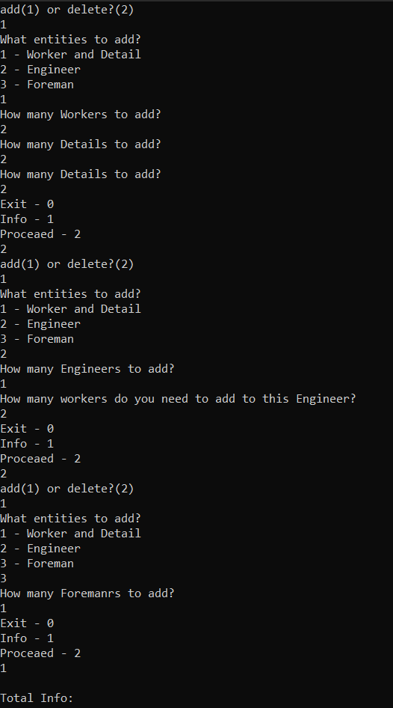

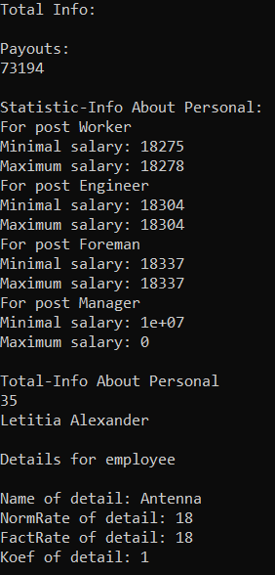

**Вывод:** Я освоил принципы полиморфизма, научился строить иерархию классов.